# DEPARTMENT OF INFORMATION TECHNOLOGY

|  |  |
| --- | --- |
| **COURSE CODE: DJ19ITL504** | **DATE:** |
| **COURSE NAME: Artificial Intelligence Laboratory** | **CLASS: TY-IT** |
| **Name: Anish Sharma** | **Rollno:I011** |

**EXPERIMENT NO.10**

**CO/LO:** Apply various AI approaches to knowledge intensive problem solving, reasoning, planning and uncertainty.

**AIM / OBJECTIVE:** Implement Explainable AI for image and text

# Code:

# Step 1: Import necessary libraries from transformers import pipeline import numpy as np import matplotlib.pyplot as plt from lime.lime_text import LimeTextExplainer

# Step 2: Load a pre-trained text classification model using BERT classifier = pipeline('text-classification')

# Step 3: Read a text file or use a string input for classification # Replace 'input.txt' with your own text file

name file_path = 'input.txt' with open(file_path, 'r') as f:

input_text = f.read()

# Step 4: Display the uploaded text print("Uploaded Text:\n", input_text)

# Step 5: Classify the text using the pre-trained BERT model predictions = classifier(input_text) print("\nPredictions:", predictions)

# Step 6: Display the top classification label top_prediction = predictions[0]

print("\nTop Prediction: {} with confidence {:.2f}".format(top_prediction['label'], top_prediction['score']))

# Step 7: LIME (Local Interpretable Model-agnostic Explanations) for Text Explainability # Define class names according to your classification labels

explainer = LimeTextExplainer(class_names=['LABEL_0', 'LABEL_1']) # Modify based on your classes

# Define a prediction function for LIME to work with BERT def predict_proba(texts):

results = classifier(texts)

# Convert the classifier output to a probability-like format (required for LIME) probabilities = [] for result in results:

probabilities.append([result['score'], 1 - result['score']]) # Adjust for binary classification return np.array(probabilities)

# Step 8: Explain the prediction using LIME

explanation = explainer.explain_instance(input_text, predict_proba, num_features=10)

# Step 9: Visualize the explanation (important words/phrases for classification) explanation.show_in_notebook(text=True) # Will open the explanation in a Jupyter Notebook

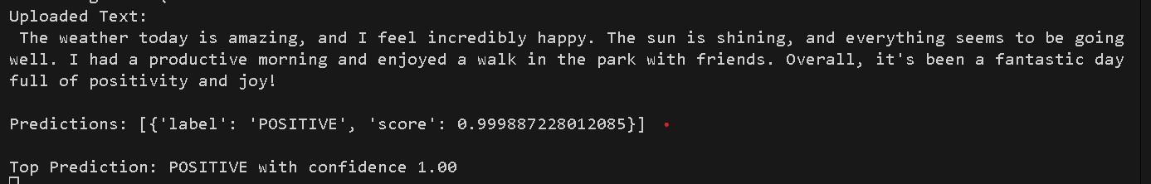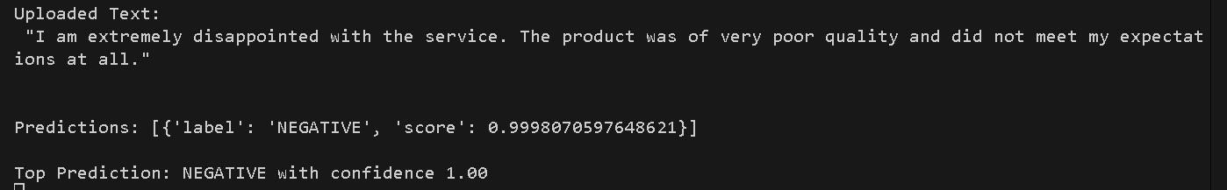Output:

# Code:

import os import keras

from keras.applications import inception_v3 as inc_net from keras.preprocessing import image

from keras.applications.imagenet_utils import decode_predictions from skimage.io import imread import matplotlib.pyplot as plt import numpy as np import lime

from lime import lime_image

from skimage.segmentation import mark_boundaries print('Notebook run using keras:', keras. version )

# Load the InceptionV3 model pre-trained on ImageNet inet_model

= inc_net.InceptionV3()

def transform_img_fn(path_list): out = [] for img_path

in path_list:

img = image.load_img(img_path, target_size=(299, 299)) x = image.img_to_array(img) x = np.expand_dims(x,

axis=0) x = inc_net.preprocess_input(x) out.append(x)

return np.vstack(out)

# Replace this path with your actual image path image_path = r'C:\Users\dhruv\OneDrive\Desktop\dwn\image.png' images = transform_img_fn([image_path])

# Visualize the image (undoing the preprocessing normalization) plt.imshow(images[0] / 2 + 0.5) plt.show()

# Predict with the model preds = inet_model.predict(images) for x in decode_predictions(preds, top=5)[0]:

print(x)

# Initialize the Lime Image Explainer explainer

= lime_image.LimeImageExplainer()

# Get the explanation explanation = explainer.explain_instance( images[0].astype('double'), inet_model.predict,

top_labels=5, hide_color=0, num_samples=1000

)

# Get the image with mask and display it temp, mask = explanation.get_image_and_mask( explanation.top_labels[0], positive_only=True, num_features=5, hide_rest=True

)

# Correct the visualization scaling for plotting plt.imshow(mark_boundaries(temp

/ 2 + 0.5, mask)) plt.show()

temp, mask = explanation.get_image_and_mask(explanation.top_labels[0], positive_only=False, num_features=10, hide_rest=False) plt.imshow(mark_boundaries(temp / 2 + 0.5, mask)) plt.show() temp, mask = explanation.get_image_and_mask(explanation.top_labels[0], positive_only=False, num_features=1000, hide_rest=False, min_weight=0.05) plt.imshow(mark_boundaries(temp / 2 + 0.5, mask)) plt.show()

#Select the same class explained on the figures above. ind

= explanation.top_labels[0]

#Map each explanation weight to the corresponding superpixel dict_heatmap

= dict(explanation.local_exp[ind])

heatmap = np.vectorize(dict_heatmap.get)(explanation.segments)

#Plot. The visualization makes more sense if a symmetrical colorbar is used. plt.imshow(heatmap, cmap = 'RdBu', vmin = -heatmap.max(), vmax = heatmap.max()) plt.colorbar()

temp, mask = explanation.get_image_and_mask(explanation.top_labels[1], positive_only=True, num_features=6, hide_rest=True) plt.imshow(mark_boundaries(temp / 2 + 0.5, mask)) plt.show()

temp, mask = explanation.get_image_and_mask(explanation.top_labels[1], positive_only=False, num_features=5, hide_rest=False) plt.imshow(mark_boundaries(temp / 2 + 0.5, mask)) plt.show()

import json

from tensorflow.keras.applications.resnet50 import ResNet50, preprocess_input import shap

# load pre-trained model and data model

= ResNet50(weights="imagenet") X, y

= shap.datasets.imagenet50() print(y) plt.imshow(X[20]) plt.show()

X = np.clip(X, 0, 255).astype(np.uint8) plt.imshow(X[4]) plt.show()

# Output:

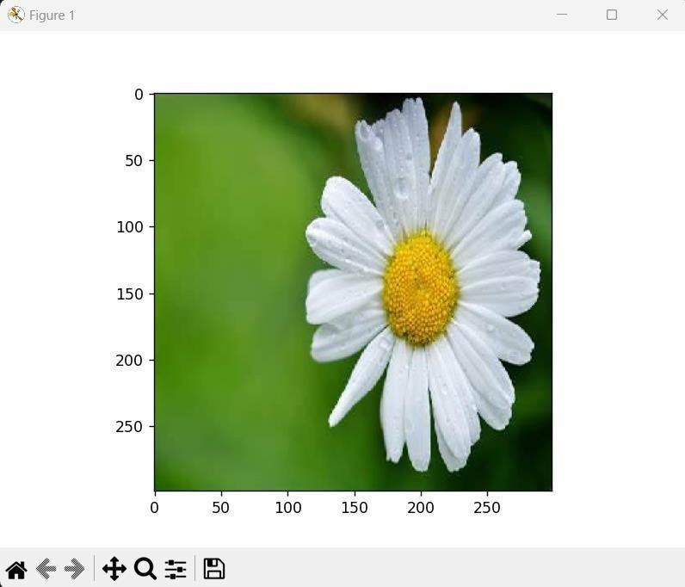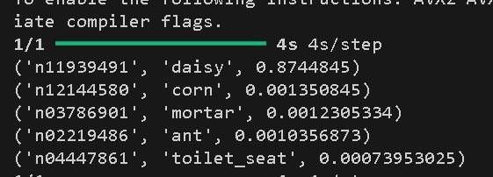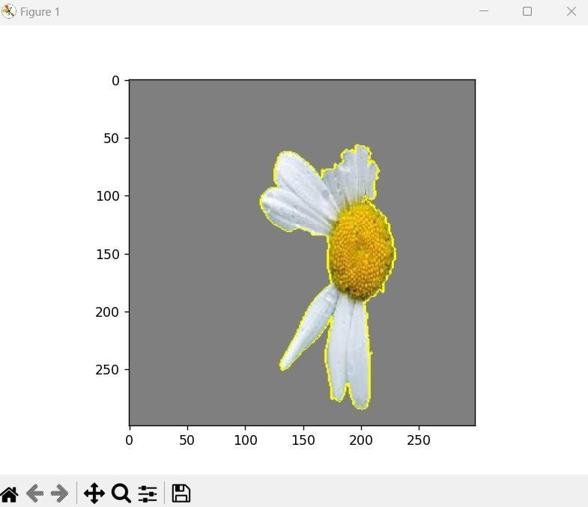

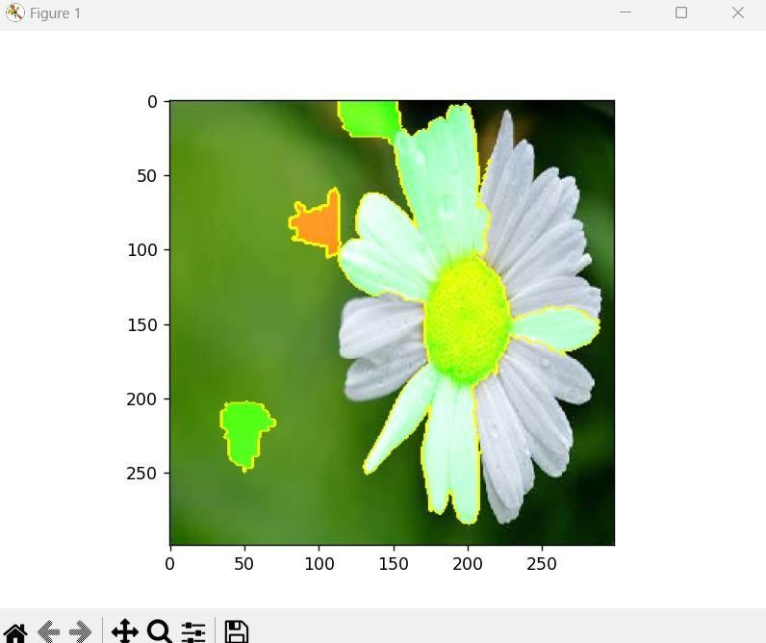

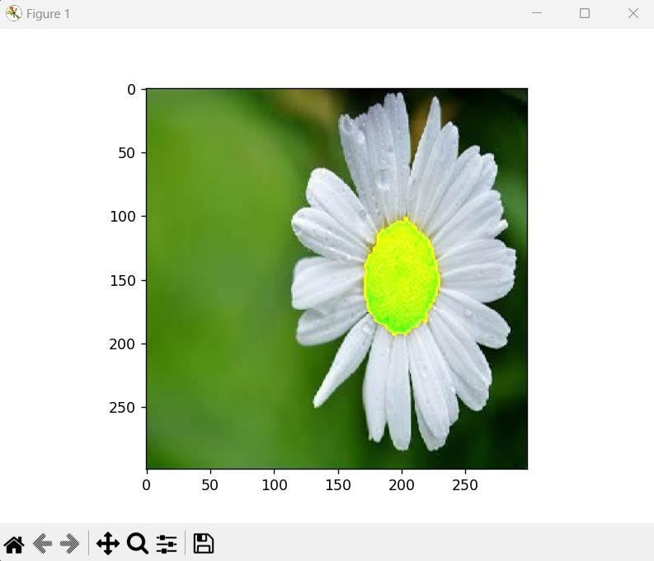



Academic Year 2023-24 SAP ID:

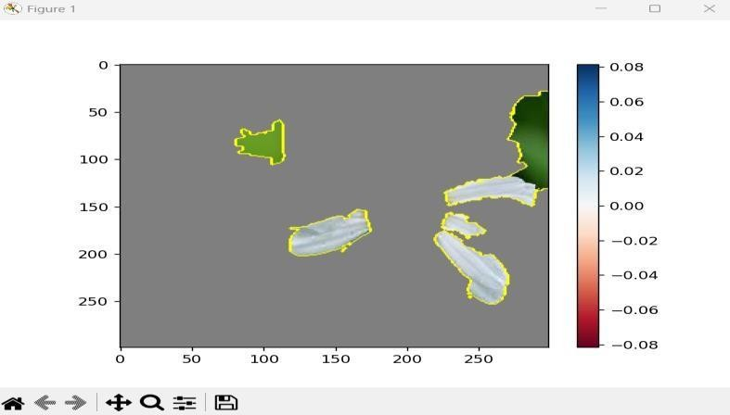

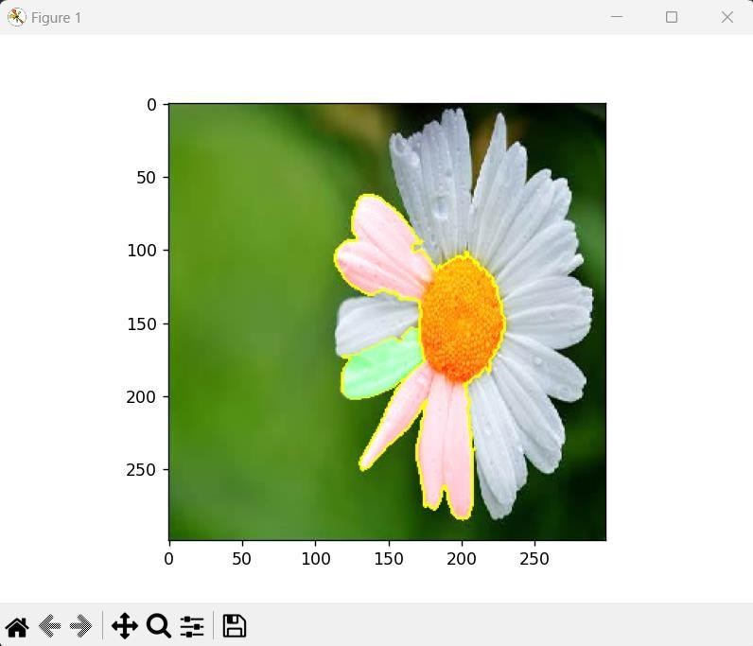

**CONCLUSION: We implemented the explainable AI. REFERENCES:**

[1] Stuart Russell and Peter Norvig, “Artificial Intelligence: A Modern Approach”, 2nd Edition, Pearson Education, 2010